**20 Ft**

**UAS Imagery Captured From Videos of Disturbance #2:**

**Pre-Disturbance (Waiting for sediment clearance from previous disturbance):**

**Shortly following start of disturbance (3 people x 20 min) [Approx 3 min for sediment to reach 1st pole at 20 ft):**

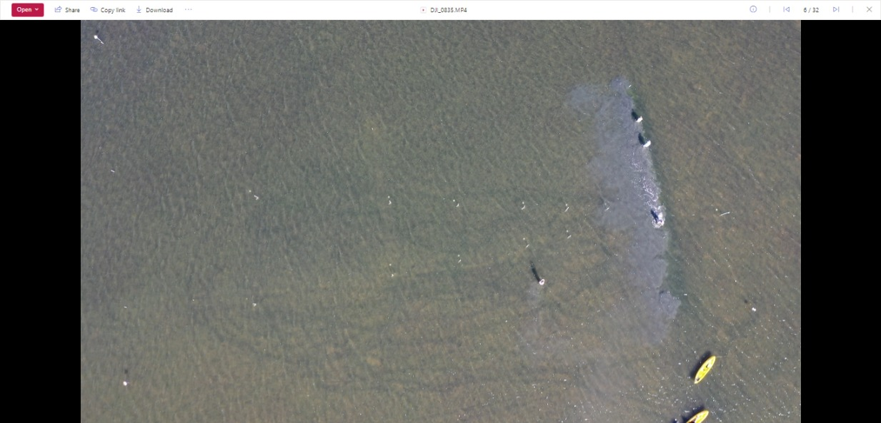

**Sediment plume reaches 2nd pole at 35 ft.:**

**Sediment plume reaches 3rd pole at 50 ft.:**

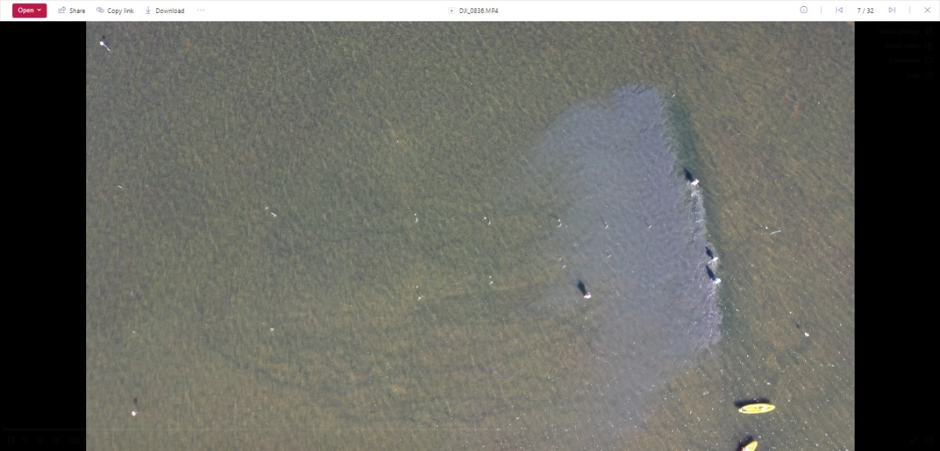

**Sediment plume reaches 4th pole at 75 ft.:**

**Sediment plume approaching 6th pole at 150 ft [Midway through Track 2]:**

**Sediment plume overtakes 6th pole at 150 ft. [Reaching 200 ft marker and proceeding into Track 1] :**

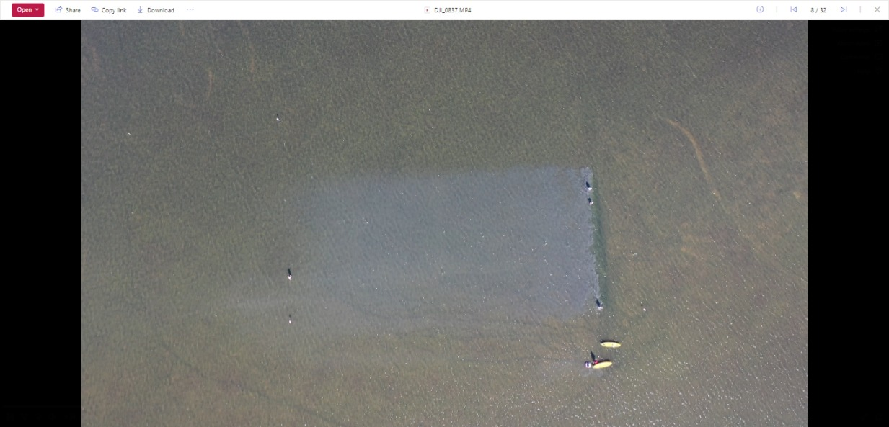

**Sediment plume approaching marker pole at 300 ft. [Through Track 1]:**

**[End of Sediment Disturbance = 20 min]**

**Post-Disturbance Collection of TSS Water Samples:**

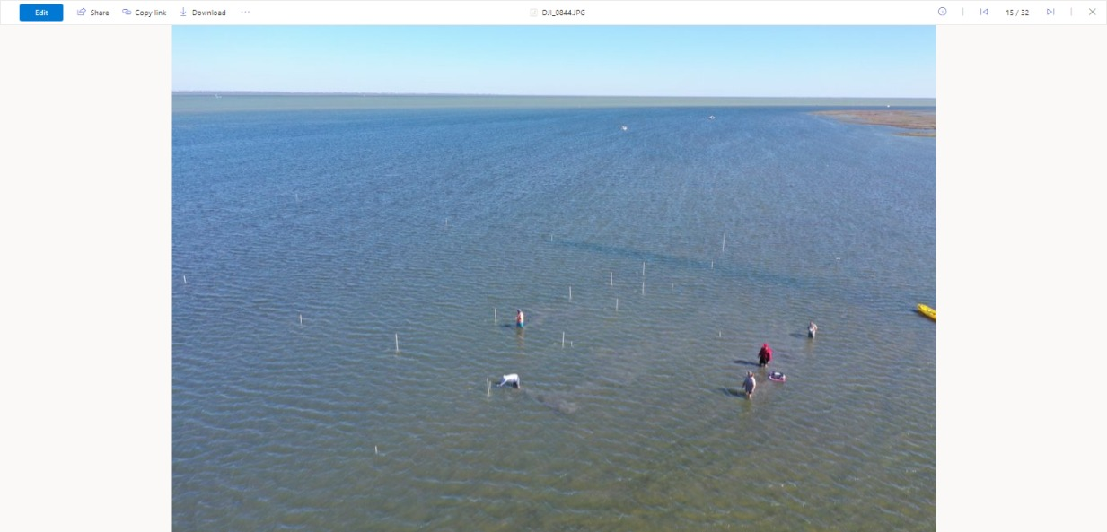

**Post 20-Min Sediment Disturbance**

